Homework (25 March 2019 ~ due date: 2 April): Digital Logic

[PROBLEM]

Explain the process in which the answer comes out in each of the following questions.

# Convert (117.23)10 to octal.

Convert decimal 117 to octal. First,117 is divided by 8 to give an integer quotient of 14 and a remainder of 5. Then 14 is divided by 8 to give an integer quotient of 1 and a remainder of 6. Finally, 1 is divided by 8 to give a quotient of 0 and a remainder of 1.

117

14 5

1 6

0 1 = (165) 8

Covert (0.23) 10 to octal

0.23 X 8 = 1.84

0.84 X 8 = 6.72

0.72 X 8 = 5.96

0.76 X 8 = 6.08

The answer, (0.23)10 = (0.1656)8

(117.23)10 = (165.1656)8

Ans. (165.1656)8

# Find the binary representation of 13510.

Convert decimal 135 to binary. First 135 divided by 2 give an integer quotient of 67 and a remainder of 0.5.Then the quotient is quotient is again divided by 2 to give a new quotient and remainder. The process is continued until the integer quotient becomes 0.

135/2= 67 + 0.5

67/2 = 33 + 0.5

33/2 = 16 + 0.5

16/2 = 8 + 0

8/2 = 4 + 0

4/2 = 2 + 0

2/2 = 1 + 0

1/2 = 0 + 0.5

The answer, (135)10. = (1000 0111)2

Ans. 1110 00012 <<FAULT

# Find (a) the diminished radix (9's) complement and (b) the radix (10's) complement of 13510.

(a) 9’s complement of 13510 = 99910-13510 = 86410

(b) 10`s complement of 13510 = 100010 – 13510 = 86510

Ans. (a) 86410, (b) 86510

# What decimal number is equal to unsigned binary number that is represented by the string of bits 11001?

110012 =1610 + 810 + 110 = 2510

# What decimal number does the signed-magnitude binary number N = 10011 represent?

The sign bit 0 for positive and 1 for negative

So, In 10011, the leading digit 1 indicates a negative number, and 0011 indicates a binary number 3 in decimal notation.

100112 = -310

Ans. -310

# Convert the signed-magnitude binary number N = 01100 to a negative value having the same magnitude.

The sign decision indicates a negative number if the first digit is 1 and a positive number if it is 0. So if the value is 01100 in negative, it is 11100.

Ans. 111002

# Represent -5 three ways with 8 bits: (a) signed-magnitude (b) signed 1's complement and (c) signed 2's complement.

If -5 is expressed in 8 bits, it is (a)10000101,. To change to 1's complement, 0 is changed to 1, and 1 is changed to 0. So the one's complement of -5 is (b)11111010,. 2's complement is (c)11111011, because it's 1's complement and you have to add 1 more.

Ans. (a) 10000101, (b) 11111010, (c) 11111011

# In the signed-2's complement system, negate the number 710 represented with 8 bits.

If 7 is represented by 8 bits, the number is 0 at the front because it is positive, and the rest is expressed as 000001112 in binary. The negative 1's complement to the number 7 is 11111000, and the 2's complement is 111110012.

Ans. given N = 000001112, 1's complement = 111110002, 2's complement = 111110012

# Find the BCD representation of 8410.

Decimal 84 is represented in BCD with 8bits as 1000 0100. Because the BCD code only looks at numbers, the number 8 is represented by binary and 1000 is 4 and it is 0100.

8410.= 10000100BCD

Ans. 10000100BCD

# Find the BCD sum of 4 + 6.

4 0100

+6 +0110

Binary sum 10 1010

Add 6 +0110

BCD sum 10000

The binary sum produces an invalid BCD digit. The addition of 0110 produces the correct BCD sum,0000(i.e.,the number 0),and a carry

Ans. 10000BCD

# Find the BCD sum (a) 370 + (-250), (b) 250 + (-370)

(a) (+370)+(-250) = +120,done in the signed-complement system:

0 370

+9 750

1. 120

(b)

Ans. (a) 0120, (b) 9880 or -120

# What is the even parity bit of 0101100?

Ans. 1

# Using the basic theorems and postulates of Boolean algebra, simplify the following Boolean expression F:

F = x'y'z + xyz + x'yz + xy'z

Ans. F = z

# Find the complement of the function F = x'yz' + x'y'z by taking its dual and complementing each literal.

Ans. F' = (x + y' + z)(x + y + z')

# Draw a logic diagram for the Boolean function F = x'y + xy'

Ans. 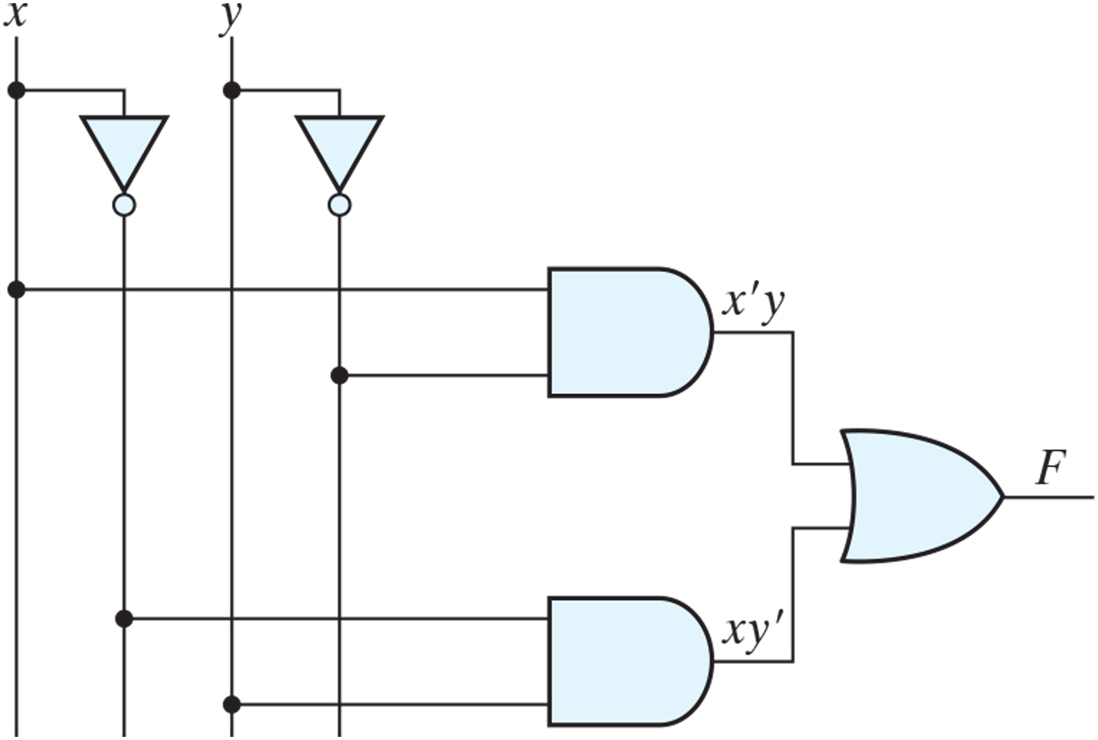

# Find a product of maxterms expression for F(x, y, z) = ∑(1, 2, 3, 5, 7)

Ans. F' = ∏(0, 2, 5, 7) and F = (x + y + z)(x' + y + z)(x' + y' + z)

# Find a sum of minterms expression for F(x, y, z) = ∏(1, 3, 4, 6)

Ans. F(x, y, z) = ∑(0, 2, 5, 7) = x'y'z' + x'yz' + xy'z + xyz

# Express the Boolean function F = A + B'C + AD as a sum of minterms

Ans. F = ∑(2, 3, 8, 9, 10, 11, 12, 13, 14, 15)

# Express the Boolean function F = x'y + xz as a product of maxterm

Ans. F = (x + y + z)(x + y + z')(x' + y + z)(x' + y + z')

# Implement the Boolean function F = xz + x'z' + x'y with (a) NAND and inverter gates, and (b) NOR and inverter gates

Ans.

|  |  |
| --- | --- |
| Ans. (a) | Ans. (b) |
|  |  |

(.end.)